Bilinear interpolation procedure.

In order to perform a bilinear interpolation on one of our points of interest we needed to calculate exactly where inside of the pixel the point was located, so that we would determine which surrounding pixels to use in our interpolation. The first thing we needed to do was to determine which pixel we were actually in, meaning we needed to calculate the row and column values for our point, the fractional parts of which gave us our position within the pixel. It should be noted, however, that in our particular case, the pixel origin was located at the center of the pixel, which made determining where we were inside of the pixel a little more challenging; the following table describes how we determined which quadrant of the pixel we were in:

Fractional X | Fractional Y | Quadrant
0.0 <= x <= 0.5 | 0.0 <= y <= 0.5 | Lower Right
0.0 <= x <= 0.5 | y > 0.5 | Upper Right
x > 0.5 | 0.0 <= y <= 0.5 | Lower Left
x > 0.5 | y > 0.5 | Upper Left
Table 1.

Once we had determined which quadrant of the pixel that we were in and chosen our three surrounding interpolating pixels we needed to choose a direction for our axes and calculate our position inside of the 2x2 grid that these four pixels represent. The following illustration shows how our axes were chosen for each quadrant.

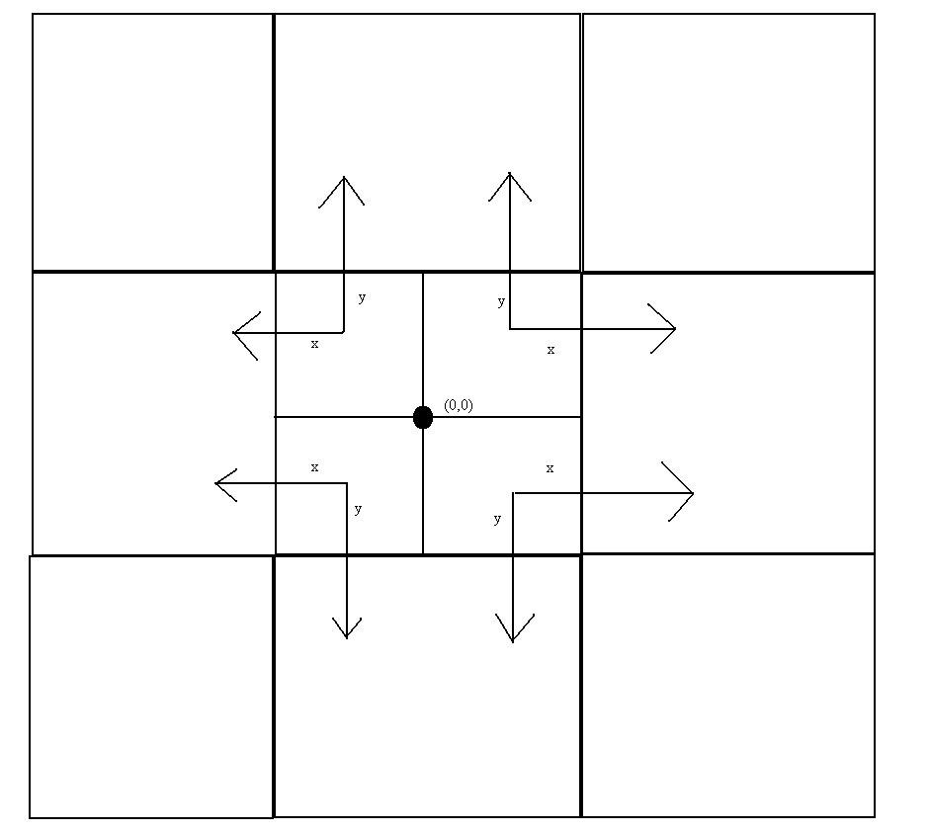

Having obtained our four needed pixel values and calculated our x and y (fractional position within our 2x2 grid) we input these values into the following formula to obtain our interpolation value:

value = (f10 – f00) * x + (f01 – f00) * y + (f11 + f00 – f01 –f10) * x * y + f00

Where f10, f01, f11, and f00 are the pixel values located at (1,0), (0,1), (1,1), and (0,0) within our 2x2 grid taking into account the direction of the x and y axes.

